SIMATS ENGINEERING
ASSESSMENT TOOL 3 – Assignment 2

COURSE NAME: STATISTICS WITH R PROGRAMMING COURSE CODE: ITA0408

COURSE OUTCOME COVERED
CO3: Construct and manipulate data frames using reshaping, merging, and file I/O
operations in R to prepare structured datasets for analysis.. (BL3, BL5)
Assessment Tool Weightage: 20%

QUESTIONS: 5 Total Marks: 100

Annexure
Assignment 2

Code of Conduct:
I G.charan surya veera manikanta(192525210) (Name / Reg No) certify that this submission is my original work
and that I have adhered to the guidelines specified for this assessment.
I understand that any violation of academic integrity rules will result in disciplinary action.

Signature of the student:

Assignment 2:
- Generate 5 Questions for your Capstone Project module
- Apply the formulae and use the relevant graph to visualize it
- Upload the file in Github link
- Save the 5 Questions and Gihub link in the Excell sheet

Name:G.charan surya veera manikanta
Reg no:192525210
Course code:ITA0408
Course Name:statistics with r programming

Question 1: Calculate Mean and Median of TDS
To calculate the mean and median of Total Dissolved Solids (TDS) values using R.
Formula:
$$\text{Mean}=\frac{\text{Sum of values}}{\text{Number of values}}$$
Program code:

TDS <- c(100, 120, 140, 160, 180, 200)

print(mean(TDS))
print(median(TDS))

hist(TDS,
main = "Distribution of TDS",
xlab = "TDS Values",
col = "lightblue")
Graph type: Histogram

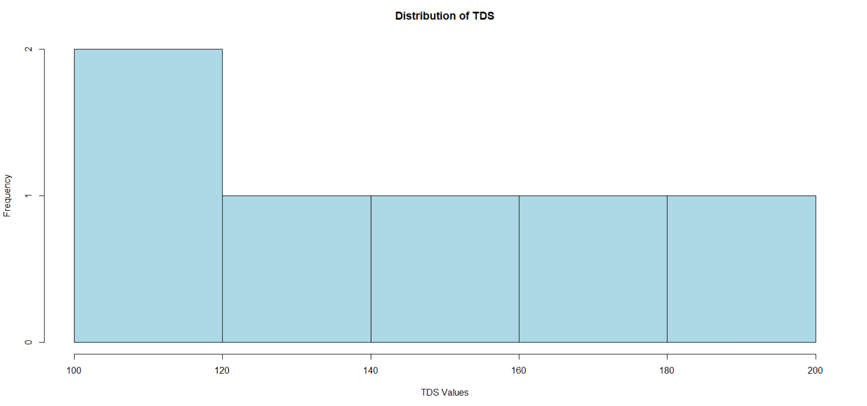
Question 2: Correlation Between pH and TDS
To calculate the correlation between pH and TDS values.
Formula: Correlation coefficient \(r\), ranging from −1 to +1.
- \(+1\): Perfect positive correlation
- \(0\): No linear correlation
- \(-1\): Perfect negative correlation
Program code:

pH <- c(6.5, 7.0, 7.2, 7.5, 8.0)
TDS <- c(100, 150, 180, 220, 250)

print(cor(pH, TDS))

plot(pH, TDS,
main = "pH vs TDS",
xlab = "pH Values",
ylab = "TDS Values",
pch = 19,
col = "blue")

abline(lm(TDS ~ pH), col = "red")
Graph type: Scatter plot
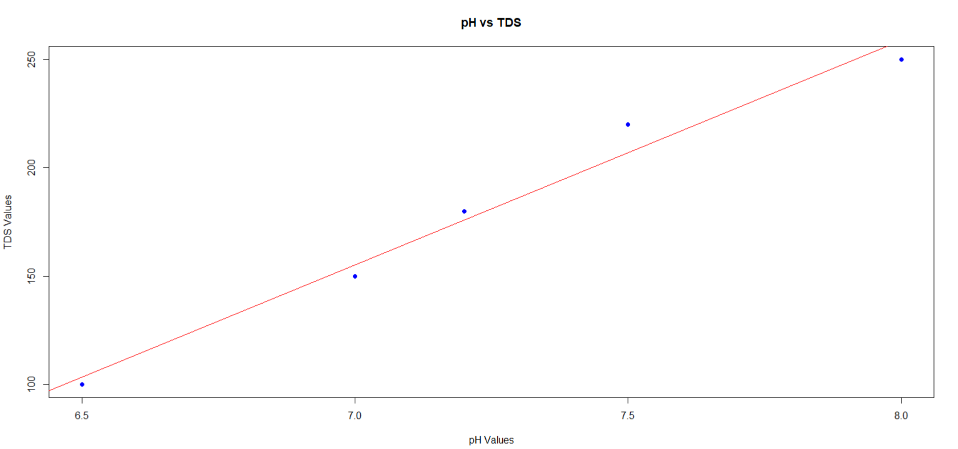

Question 3: Calculate Standard Deviation of Turbidity
To calculate the standard deviation of turbidity values and measure their variation.
Formula:
$$s=\sqrt{\frac{\sum{{\left(x-\overline{x}\right)}^{2}}}{n-1}}$$

Program code:

turbidity <- c(2, 3, 4, 5, 6)

print(mean(turbidity))
print(sd(turbidity))

hist(turbidity,
main = "Turbidity Distribution",
xlab = "Turbidity Values",
col = "lightgreen")
Graph type: Histogram
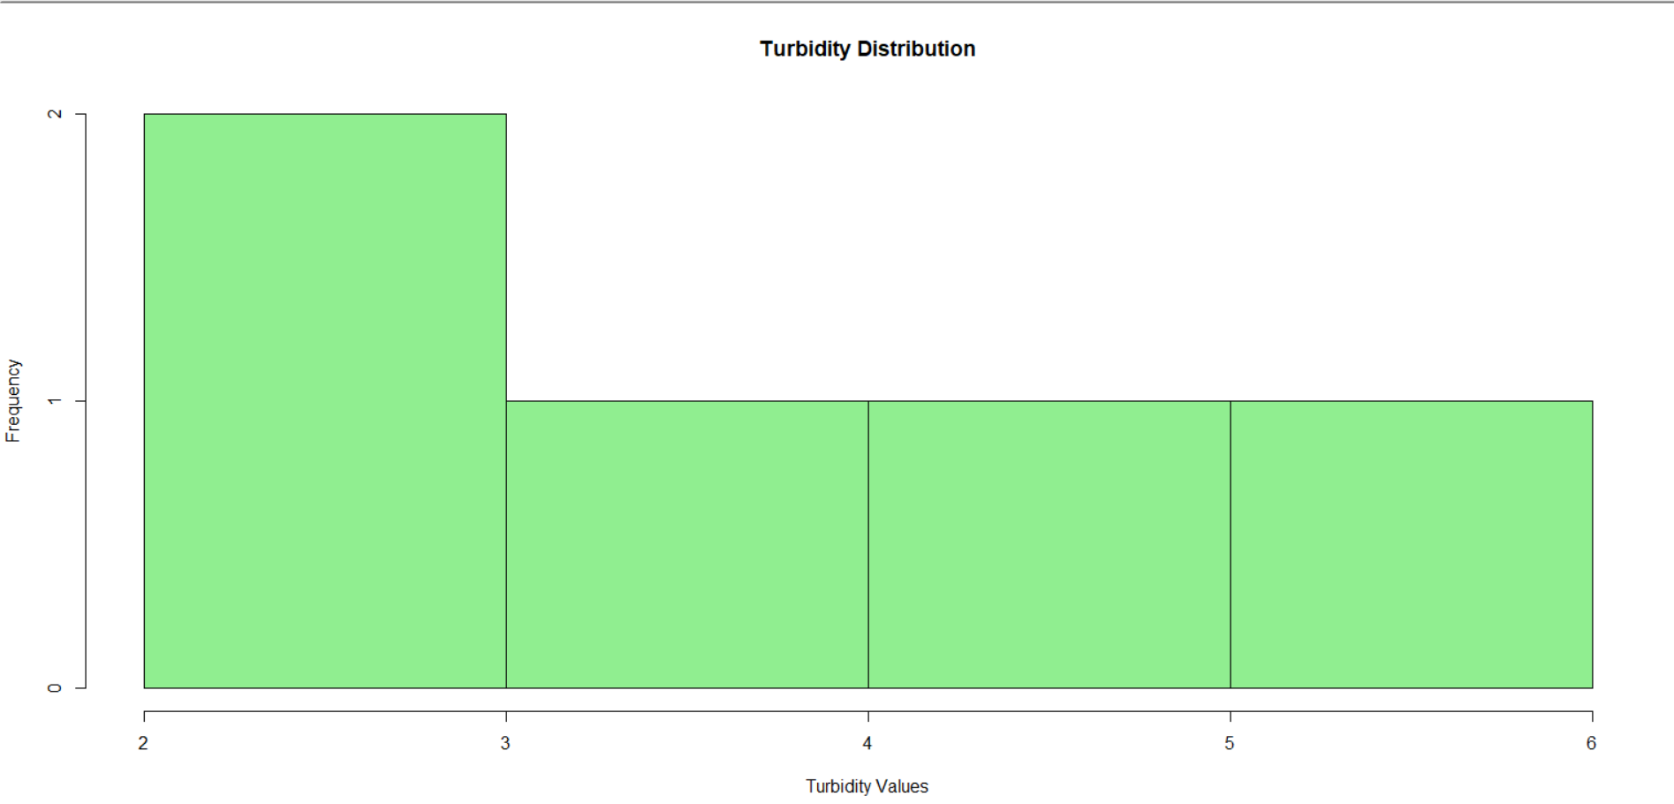
Question 4: Detect Outliers in TDS Values
To identify unusually high TDS values using the IQR method.
Formula:
$$IQR=Q_{3}-Q_{1}$$
Upper limit:
$$Q_{3}+1.5×IQR$$
Program code:

TDS <- c(100, 120, 130, 140, 150, 160, 170, 500)

Q1 <- quantile(TDS, 0.25)
Q3 <- quantile(TDS, 0.75)
IQR_value <- IQR(TDS)

upper <- Q3 + 1.5 * IQR_value

outliers <- TDS[TDS > upper]
print(outliers)

boxplot(TDS,
main = "TDS Outlier Detection",
ylab = "TDS Values",
col = "orange")
Graph type: Boxplot
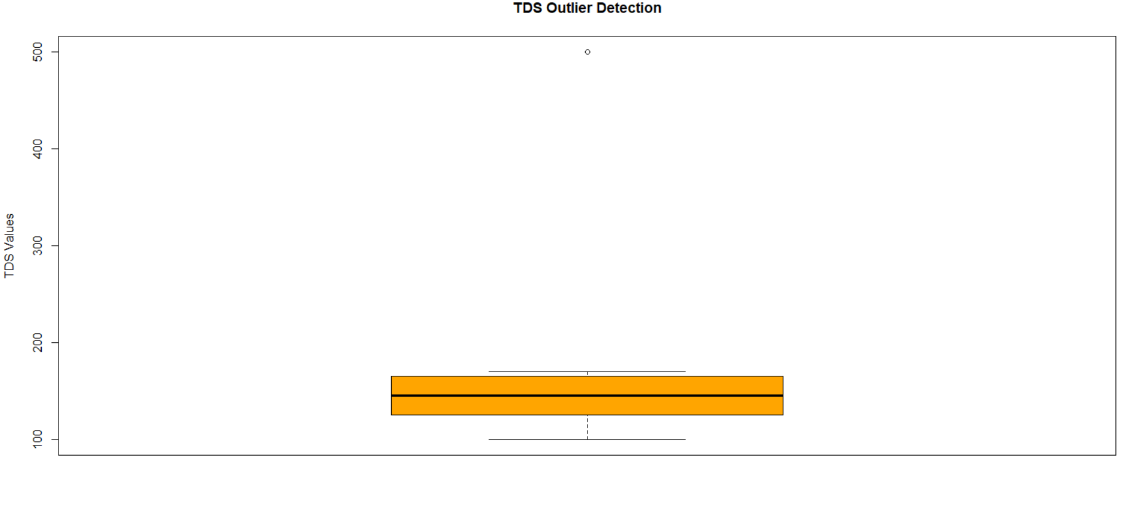
Question 5: Calculate the Percentage of High-TDS Samples
To calculate the percentage of samples whose TDS values exceed a chosen threshold.
Formula:
$$\text{Percentage}=\frac{\text{High-TDS samples}}{\text{Total samples}}×100$$
Program code:

TDS <- c(100, 150, 250, 300, 180, 350)

threshold <- 200

high <- sum(TDS > threshold)
total <- length(TDS)

percentage <- (high / total) * 100

print(percentage)

barplot(TDS,
main = "TDS Sample Analysis",
xlab = "Sample Number",
ylab = "TDS Values",
col = "skyblue")

abline(h = threshold, col = "red", lwd = 2)
Graph type: Bar chart
